**DAILY ONLINE ACTIVITIES SUMMARY**

|  |  |  |  |  |  |  |  |
| --- | --- | --- | --- | --- | --- | --- | --- |
| **Date:** | **27 may 2020** | | | | **Name:** | **Amrutha G** | |
| **Sem & Sec** | **4th sem, 2nd year** | | | | **USN:** | **4al18cs006** | |
| **Online Test Summary** | | | | | | | |
| **Subject** | | **OBJECT ORIENTED CONCEPTS (18cs45)** | | | | | |
| **Max. Marks** | | **30** | | **Score** | | **25** | |
| **Certification Course Summary** | | | | | | | |
| **Course** | **Introduction to digital marketing** | | | | | | |
| **Certificate Provider** | | | **Udemy** | **Duration** | | | **2.5 hours** |
| **Coding Challenges** | | | | | | | |
| **Problem Statement:1 program** | | | | | | | |
| **Status: Executed** | | | | | | | |
| **Uploaded the report in Github** | | | | **Yes** | | | |
| **If yes Repository name** | | | | https://github.com/AMRUTHAGANESH/lockdown-codings | | | |
| **Uploaded the report in slack** | | | | **Yes** | | | |

**Online Test Summary:**

Today **OBJECT ORIENTED CONCEPTS (18cs45)** was conducted of first module. Total marks for the test was 30.

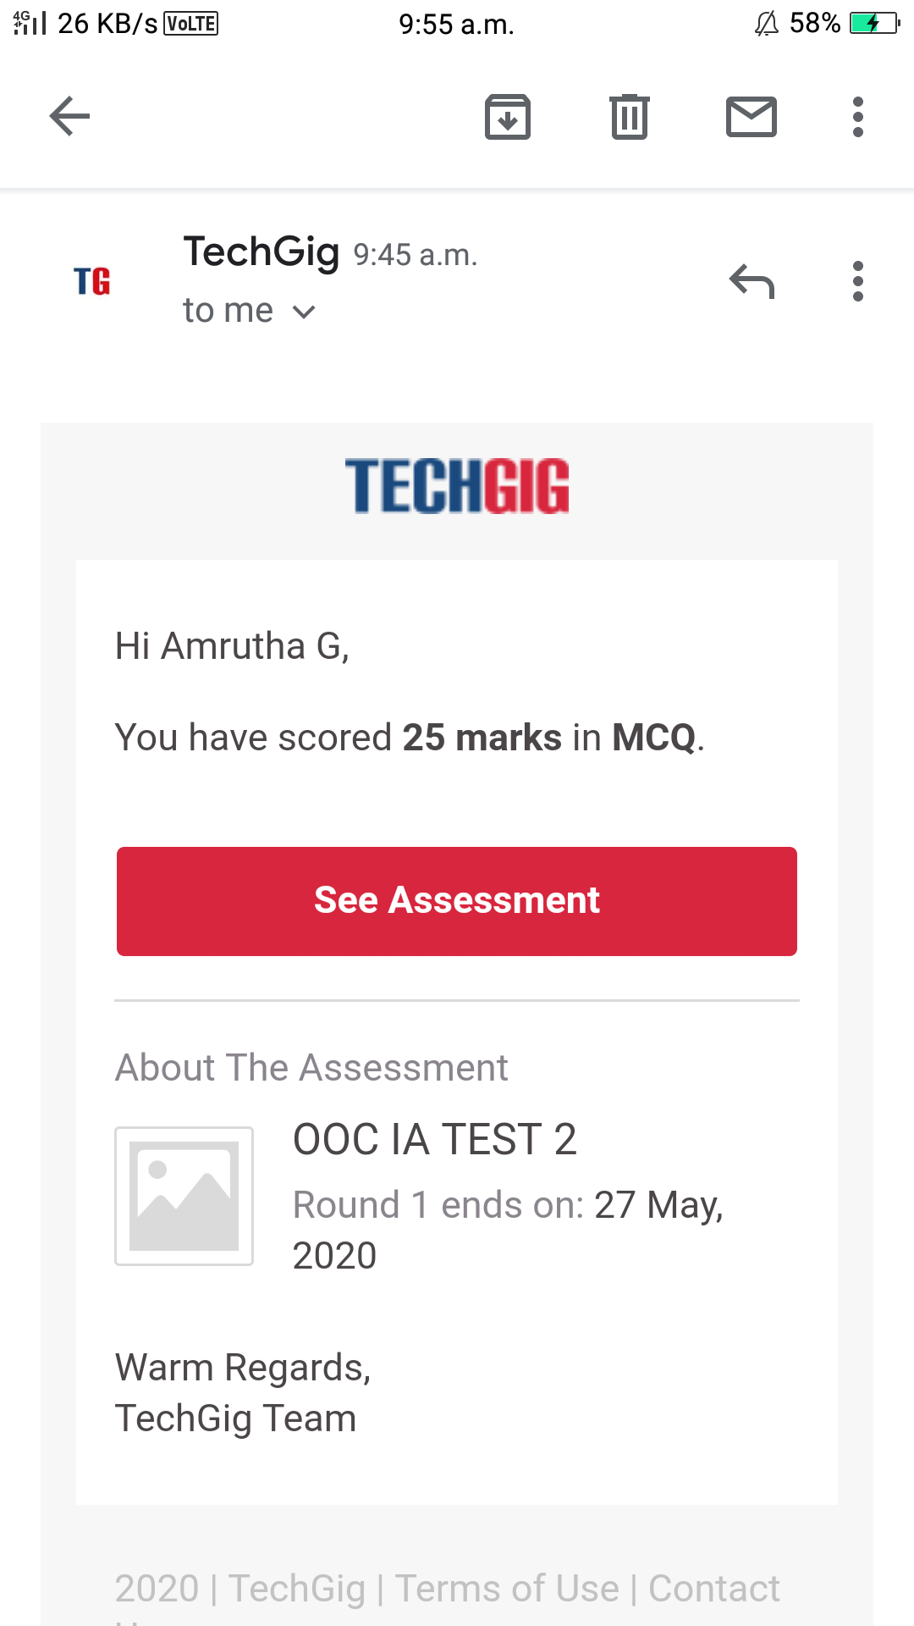

**Certification Course Summary:** **Today I learnt about Addset set up guide and also learnt about what is custom audience**

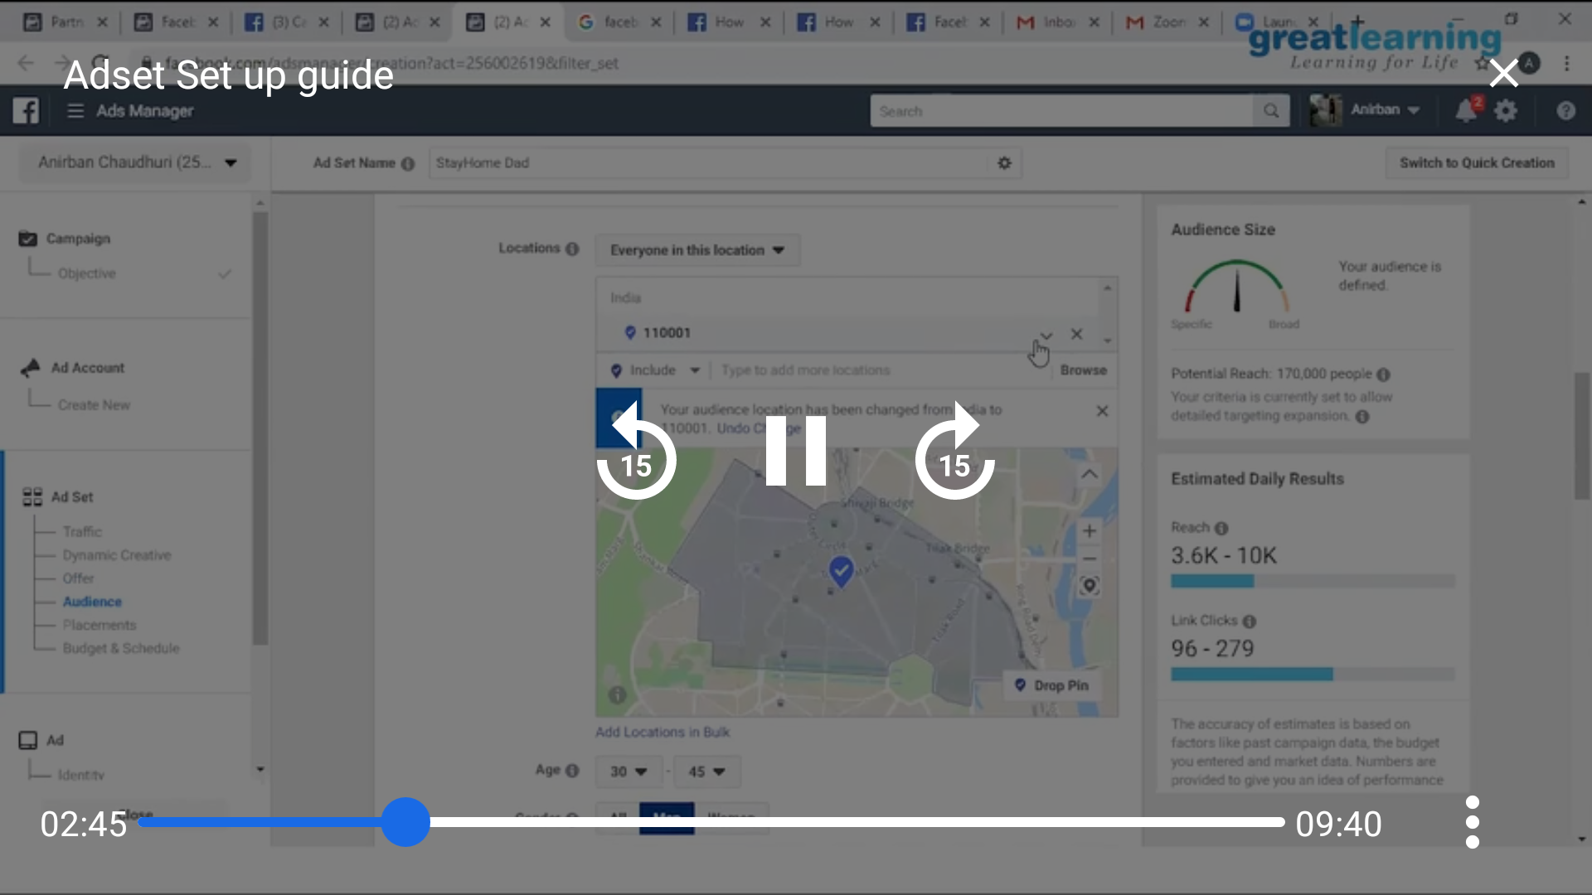

2nd one

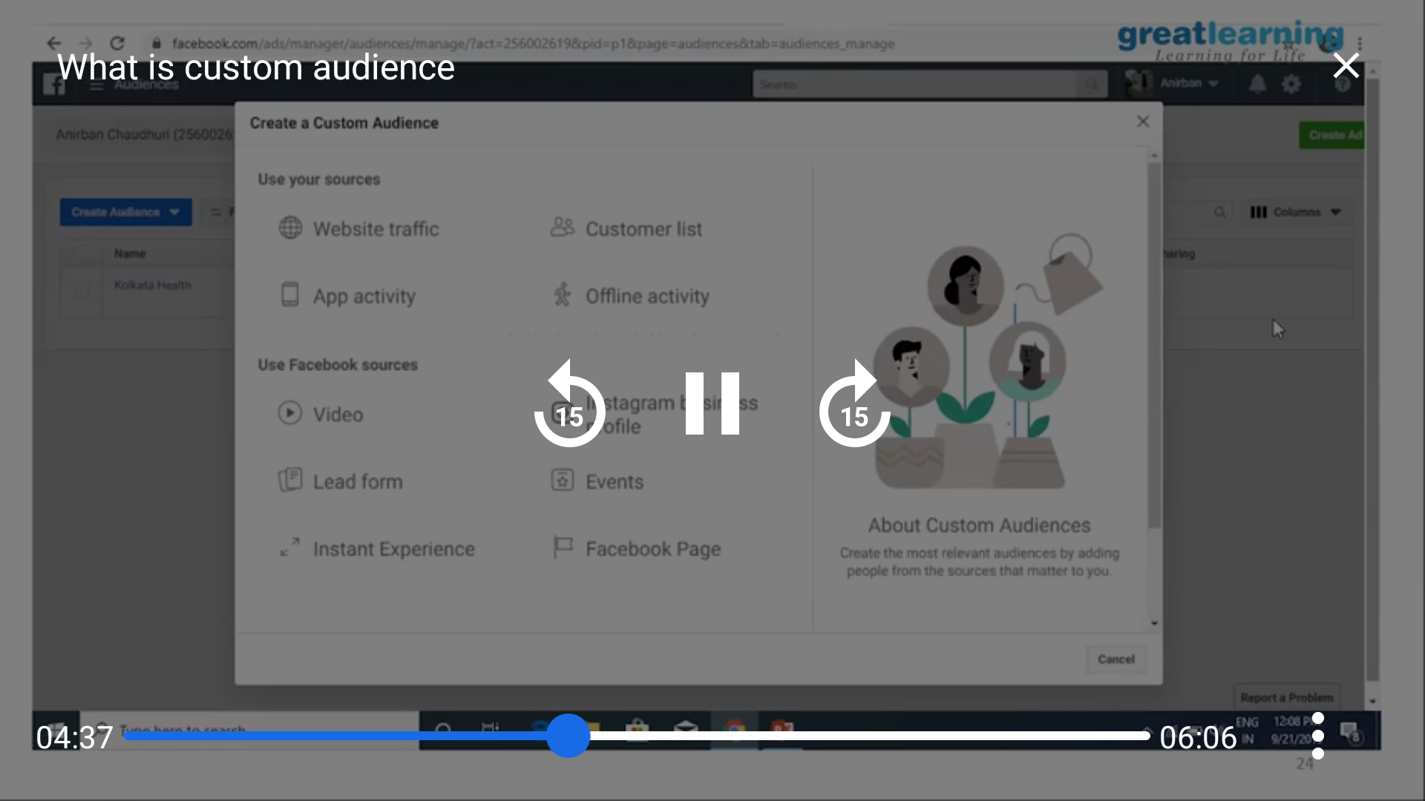

**Coding Challenges:**

Today I solved 1 coding challenge,

1. **In Bubble sort, each pass consists of comparison each element in the file with its successor (i.e. x[i] with x[i+1]) and interchanging two elements if they are not in the proper order. The array may be sorted in any pass. If the array is sorted, then remaining passes should be skipped off. Write a C Program to sort an array of integers in ascending order and display the sorted array and Number of passes performed for sorting**

